**CSC3231 Game Design Coursework Assignment - Game Design Document**

**Important note**: a list of all gameplay assets can be found as a PDF in the GitHub repository. Please refer to this for any licence concerns.

**Section 1 - Gameplay Demo Video**

Link: <https://youtu.be/YFcyO_4gGu0>

**Section 2 - Concept**

Silent Obsidian is a first-person action game centred around harmonious combat mechanics and interactions with a large emphasis on fluid movement, boosting player expression by enabling different playstyles. The project takes inspiration from the Action, Hack & Slash and Platformer genres/subgenres to achieve this including melee and ranged combat, combos, vertical play, and resource management. The game takes place in the space between realities: The Eternal Divide. Regions of The Divide (levels) function like arenas, where the player will encounter enemies that have a clearly defined set of combat traits, but offer complexity and challenging scenarios with synergetic squad composition as well as environmental opportunities. The objective for each level is to defeat all enemies and reach the portal. Score is earned by landing hits, reflecting mastery of combat mechanics leading to a positive feedback loop and encouraging engagement to keep playing to improve and earn a higher score.

**Section 3 - Player Experience**

**Player-Centric Design & System-Centric Design:**

Rules govern how players interact with the game system and so are important to consider. There are three types of rules (Salen & Zimmerman, 2003). The first, “Operational”, include explicit rules for the player such as cooldowns, attack costs, which provides players clarity and visibility of system status. The “Constitutive” rule here refers to the internal logic of the game, which will include environmental effects planned to be in the level that are not immediately apparent and will provide emergent gameplay. Players may find this exciting as they feel they have made a discovery, improving engagement as they may want to explore the level more to find new things. Lastly “Implicit” rules in this game are planned through risk-reward balancing, hopefully allowing players to feel rewarded for learning rather than attempting to find exploits.

The game is planned to use transitive relationships/balancing with elements that have intrinsic value (resource management system). Each attack will be designed with a cost and benefit, promoting diverse playstyles as each player will optimise things for their own preferences.

**Target Audience/Player Taxonomy:**

This game is intended for novice and experienced audiences and so will mean the design of the gameplay can afford to be more complex and employ high skill curves for a rewarding experience when it comes to mastery. In terms of player taxonomy, the overall game would firstly appeal more to “Conqueror”, a personality/gamer type who enjoys the employment of strategies and tactics as I envision them to be attracted to mechanics such as resource management and decision-making with a good level of depth around attack types. The combo mechanic and enemy squad synergies add more complexity and therefore depth which should draw in Conqueror players. The “Manager” should also be interested in this game as that personality enjoys strategic/tactical thinking too, likely finding the resource management offered engaging as it requires careful balancing of cost versus benefit for attacks. Finally, the “Daredevil” is a personality who enjoys action-based games. This game offers high risk and reward and fast paced action. This game’s emphasis on timing, high skilled curve combat, and dynamic situations should provide constant adrenaline filled moments that would be attractive to the Daredevil type of player.

**Flow & MDA (Mechanics, Dynamics & Aesthetics) Framework:**

Overall, the players will be rewarded intrinsic rewards, such as the satisfaction of mastering combat styles, completing a level, and getting the highest score they can. This contributes to a positive feedback loop. A negative feedback loop will be employed simply when the player loses a game. The use of both should create a balanced feedback loop overall, where players feel the game is fair and negative feedback is due to their own actions, as opposed to anything the game directly does.

The game will attempt to meet several aesthetic (emotional) goals. The first goal is to invoke a sense of challenge with tactical depth due to the planned interactions between player attacks/abilities and enemy types that synergise with each other. Secondly, I am aiming to give players a sense of complete control which fluid movement mechanics and intuitive combat. The planned satisfaction of pulling off a well-timed combo coupled with a dodging mechanic for example enhances this appeal. I also aim to give players a sense of expression, with players being able to tailor their playstyle by creatively combining attacks and movement mechanics. For example, they could create aggressive melee or hit-and-run tactics. Lastly the visual style and level structure should contribute to a sense of fantasy, improving immersion and player engagement for those that enjoy narrative in a game.

**Section 4 - Game Mechanics**

**Mechanic 1 - Vector Launch:**

This should act as a super jump mechanic - giving players the option to use it for movement or for a quick escape. This should have a cooldown to make it an opportunistic tool. The jump height should enable players to escape situations but not so high that it breaks the flow of combat waiting to fall back down.

**Mechanic 2 - Vector Drive:**

This mechanic should allow the player to quickly move (boost) in any direction, allowing for gameplay opportunities such as dodging and tactical positioning. The Vector Drive should last around 0.5 seconds, after which there should be a cooldown of around 2 seconds to ensure it remains a tactical move and not make them almost invulnerable.

This mechanic complements the melee attacks for aggressive playstyles as they allow the player to engage or disengage quickly. Combined with the Vector Launch, this will allow players to fine tune movements and total control of both their momentum and positioning, something that this game places an emphasis on. Utilising precise movement and more emergent, unplanned behaviour on the player’s part encourages a high skill ceiling/curve for players who can master both timing and position.

**Mechanic 3 - Elemental Charge**

While technically dealing with three separate mechanics, a shared concept exists between them: resource management. Players should start with 10 charges which will be regenerated over time (regeneration should be adjusted during playtesting to prevent players relying on certain attacks).

**Mechanic 4 - Hydro Attack**

This should be a light attack, costing the least elemental charge and doing the least amount of damage.

**Mechanic 5 - Inferno Attack**

The Inferno attack should be the middle ground in terms of damage and elemental charge cost.

**Mechanic 6 - Tempest Attack**

Ranged, projectile based attack, and high risk-reward with the highest elemental cost and the highest damage output. This attack should be effective for defeating enemies but punishes the player if they miss.

**Mechanic 7 - Combo**

Performing a Hydro attack quickly followed by an Inferno attack (within 5 seconds) does double damage. This mechanic reinforces the need for good resource management from the player to pull off effectively due to the combined cost of attacks, ensuring balance in the resource system so that players don’t become overpowered.

**Mechanic 8 - Cryo Enemy**

A fast, melee-based enemy. Stronger against ranged playstyles as they close the distance quickly. Complimentary to the shrouded enemy as unlike them they can do short-range damage.

State Machine Diagram for AI implementation:

**Mechanic 9 - Shrouded Enemy**

This enemy should perform some kind of high damage ranged attack. No short range/melee attack. Easy to dodge but punishes players for not having good awareness. Synergises with the Cryo enemy as it acts as an artillery unit, staying a certain distance away (e.g. 10f) from the player and directly firing on them or providing cover and support for the Cryo enemy.

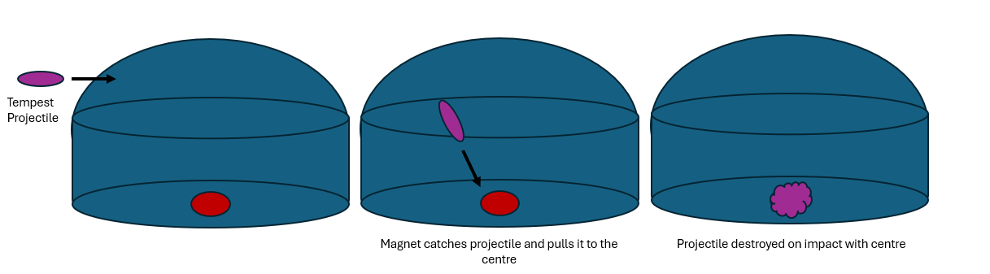**Mechanic 10 - Projectile Magnet**

An environmental hazard that attracts and destroys projectiles and has a defined area of effect.

**Section 5 - Structure/Level Design**

The level design will have an arena-based design structure to place combat at the centre of player experience, as opposed to navigating an exploring a level which may be more prominent in games more focused on narrative, such as action/adventure games.

Instead of platforms there are towers for the player to jump on to out manoeuvre enemies. More open levels and little cover would mean it would be too easy for AI to track players and there would be little cover to escape enemies, and in turn the game would become too intense. Also, the player wouldn’t have the time to form effective strategies. Towers will act as a way for players to escape enemies or gain vantage points and plan. The Vector Launch mechanic allows for quick movement and combined by traversing from height, provides opportunities for ambushes or retreat.

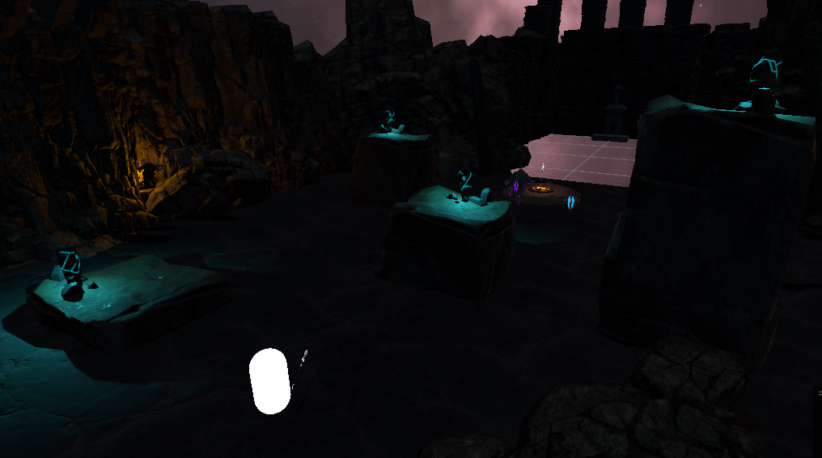

The use of the towers creates chokepoints. This means the player can attempt to funnel enemies into certain advantageous areas to isolate threats or use high-damage attacks like the Tempest, Inferno, or combo attacks to greater effect due to players being able to unleash devastating attacks in short time due to the higher concentration of enemies.

The limited open space in the level lets players to utilise the Vector Drive mechanic for better tactical positioning, in turn allowing players who prioritise movement in their playstyle to thrive. These open spaces challenge the player’s ability to avoid enemy attacks, especially if they get caught off guard and find themselves in an open area. This ensures gameplay remains varied and engaging by breaking up any predictable flow.

The Projectile Magnet environment mechanic forces players to adapt in real time by limiting the effectiveness of ranged attacks, while also adding variety to combat. It can be used as part of a strategy provide a break from enemy projectiles and capitalise on the weakness of Shrouded enemies.

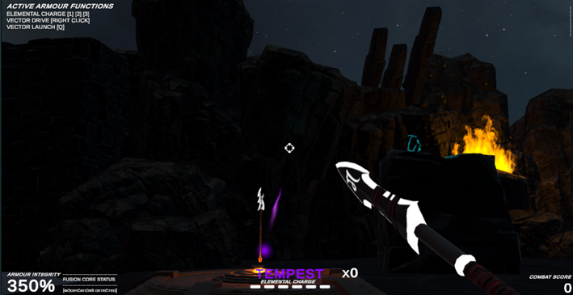

The player’s Tempest projectile getting attracted to the magnet

Once players defeat all enemies, the invisible gate blocking the portal area will lower. Jumping in the portal completes the level. To make it easily understandable it was designed to look like a distinct area, making players question what is there and wanting to explore it.

**Section 6 - Playtesting**

Currently all main functionality is implemented, including movement, attacks, and enemy AI. To improve the game, I conducted playtests with a small number of people and iterated on the game using feedback and using different testing types to check the functionality and gather more feedback. I used acceptance testing to ensure features were functioning as intended, exploratory testing to test for unexpected behaviour, and usability testing to reinforce good game design.

**Iteration 1**

During playtesting it was found that the Tempest projectiles being fired straight were too easy to use and often too hard to dodge from the Shrouded AI when in close quarters as there was little time to react. Having the projectile being fired in this way was also too predictable. In response I changed the Tempest projectile to use gravity, requiring it to be fired at the correct angle to hit its target, demanding a higher level of skill. This meant the AI performed calculations to be able to hit the player.

To test this, I used an acceptance test to test for expected behaviour from the AI, where the test case was to see if the AI can calculate the correct angle to hit the player and the expected outcome being that the AI consistently lands projectiles near or on the player. Testing showed that the enemy was able to accurately hit the player, however struggled when the player was moving as they were aiming at the player’s current position. It was found through playtesting that this was a good balance however since it provided some challenge but allowed for an acceptable amount of reaction time from players.

I also conducted a usability test. The test was to see if players understood the new projectile mechanic. After some practice players demonstrated decent proficiency, and felt that it positively increased the skill curve of the game overall by being less predictable

**Iteration 2**

This iteration of development focused on improving the combat experience further. Playtesting indicated that Tempest attacks, while using the idea of high-risk high reward, were too inconsistent to use simply in comparison to the melee-based attacks. In addition, feedback indicated that Inferno attacks weren’t that much different to Hydro attacks, and didn’t offer anything interesting other than doing more damage and costing more compared to Hydro attacks.

To improve this, both attacks now have a unique effect to ensure that they promote varied playstyles. Tempest attacks will stun enemies, locking them in place temporarily, and Inferno attacks will knock back enemies.

The knock back effect was chosen for the Inferno attack as since it costs more than a Hydro attack, players will have to consider their choices more to use it at the right opportunity, ensuring that there is a trade-off and enforcing a balance in regard to system-centric design. For the change to the Tempest attack, the even higher cost rewards players for being able to use this attack effectively.

For this I conducted usability testing to assess if players could recognise when to use higher cost attacks effectively. Findings showed that experienced players show good resource management, however lower skilled players often ran out of Elemental Charges and had to retreat, though discussions were had that indicated with time their tactical awareness would improve.

I used acceptance testing too, with one case being the stun effect of Tempest attacks, and the other case being testing the knockback effect of Inferno attacks. The expected outcome for test one was that enemies are immobilised and unable to act during the stun duration, and for test two that enemies are pushed back visibly, with the effect affected by terrain and obstacles. I tested these by using a Tempest attack on both enemy types, and by hitting the two enemy types with Inferno attacks. The tests showed that the stun effect consistently stopped enemies for the expected duration, and enemies were knocked back with appropriate force, where obstacle stopped momentum in certain scenarios.

I also used exploratory testing. The test case for this was to see how combining stun and knockback mechanics worked together. The attack effects functioned as intended with no stacking issues, and players agreed the combination strategy added more depth to combat.

**Iteration 3**

This iteration focused on improving the enemy AI. Players noted that AI didn’t seem to be reacting appropriately when the player was out of the line of sight and appeared to just stay in place. In addition, the Shrouded enemy was usually locked in place when firing, which players noted made them an easy target in some situations. Lastly sometimes the enemy AI became stuck in one place, which needed resolving.

To fix this, I implemented a search state within the State Machine which increases perceived smartness of the AI while also increasing its effectiveness of finding the player again. The search state works by picking a nearby location and travelling to it. By traversing the area there is a greater chance it will find the player again and gives the impression that the AI is searching. To improve the Shrouded enemy and stuck AI. I added a teleport feature, with a particle effect to make sure players new this was an intended effect.

I used acceptance testing, with the first case and goal to ensure the AI behaves appropriately in the search state when the player is out of line of sight. I conducted this test by breaking line of sight with the AI in various scenarios and observing if the AI transitions to the search state. The first implementation of this state had AI be stuck in place as the search position was generated after every update. I fixed this by ensuring that they reached the destination before searching again. Retesting showed that the AI successfully transitioned into the search state, which I observed by watching and with debug logs. The next test case was to verify the teleport ability triggers appropriately and included the particle effect. Engaging the AI in combat and observing its behaviour in situations where they became stuck or stationary showed that the AI will teleport to a nearby location after being immobile for the set amount of time, but the particle effect was clear but needed slight adjustments to positioning on the character model for better visibility.

I also used usability testing to determine if players recognised the AI is actively searching when out of line of sight. Most players noticed the AI moving to search locations and felt it was more engaging and afforded more complex and competitive interactions. A few players suggested adding visual and audio cues to emphasise the AI's behaviour.